**AdvoKit**

Toolkit for Writing Proclamation 2.0  
It’s Safe Kids Day!





Introduction

This is an update of an Advokit we provided to you to help you seek a proclamation in your city, county or state. We are providing it to you now because we are hoping some of you might seek to advocate a proclamation for Safe Kids Day.

**For Safe Kids Day Events:** Let’s all seek an official proclamation by a local or state government leader to pump up the volume of Safe Kids Day. It is an excellent way to create community and media awareness and make your invitations to your event all the more special.

**For Other Events and Occasions:** You may have the occasion to want your state or local government to issue a proclamation to put the spotlight on a separate Safe Kids event or initiative. It could be Child Passenger Safety Week, International Walk to School Day, a sports safety clinic or similar initiatives. This toolkit will provide you with the materials to put together a proclamation. You might also want to provide an official looking certificate of recognition or appreciation, and we provide you with an example at the end of this Advokit.

This toolkit will provide you with the following:

* How to Write a Proclamation
* How to Get the Proclamation Proclaimed
* How to Write a Letter Asking for the Proclamation
* Sample Safe Kids Day Proclamation
* Proclamation Boiler Plate

* Sample Proclamations
* Sample Certificate of Recognition

How to Write a Proclamation

* Assemble facts that relate to the issue at hand. Try to have some general statistics that apply to the whole country and some that apply specifically to your state, county, region or city. You may want to have some statistics just for this year as well as an overall statistic for all the years that we have been measuring that statistic. Examples are as follows:
  + The Mayberry Children’s Hospital reports that in 2012 its emergency room saw more than 6,000 kids for sports related injuries.
  + According to the National Highway Traffic Safety Administration, the usage of child restraint systems improved from 88% in 2002 to 91% in 2011.
  + In 2010, more than 400,000 children were non-fatally injured in motor vehicle-related incidents.
  + In 2011, more than 46.5 million children played team sports and in 2012 more than 1.35 million children ages 19 and under were seen in emergency rooms. **t**
* Use a clever name for the day/week that you are proclaiming, like Safe Kids Day!
* If the event was inspired because of a tragedy involving a child, somehow delicately use the name of the child in the document and/or the event. (Always make sure you have the family’s permission to do so.)

How to Get the Proclamation Proclaimed

* Check the website of the public official from whom you are requesting the document. He/she may have a sample and process that you should follow. This is what the [Governor of Kansas](http://governor.ks.gov/serving-kansans/constituent-services/proclamation-guidelines) provides and the [Mayor of Lauderhill, Florida](http://lauderhill-fl.gov/RMP.pdf). Try to get a direct contact.
* Act early! It can take weeks for a proclamation to go through government systems.
* Make sure you invite the public official from whom you are seeking the proclamation to your event.
* In smaller cities and towns, sometimes the Mayor will issue the proclamation in person. If he’s or she has done this before, ask.
* Use your home page and social media to make the proclamation go viral.
  + [Honolulu Proclaims a Halloween Pedestrian Day](http://www.hawaiinewsnow.com/story/7282453/mayor-hannemann-proclaims-halloween-pedestrian-safety-day)
  + [Cheraw, South Carolina’s Mayor Proclaims a Day Heat Start Awareness Day](http://www.cheraw.com/news_article.php?Cheraw-Mayor-Proclaims-Head-Start-Awareness-Day-24)
  + [Denton, Texas Mayor Declares “National Wear Red Day” to mark awareness about heart disease in women](http://www.dentonrc.com/local-news/local-news-headlines/20140206-denton-mayor-declares-friday-national-wear-red-day.ece)
  + [Boise, Idaho Mayor Proclaims a “Pat’s Run Day” in honor of the NFL player who was found to be killed in action in Afghanistan of friendly fire](http://mayor.cityofboise.org/news-releases/2013/04/mayor-bieter-proclaims-'pat's-run-day'/)

How to Write a Letter Requesting a Proclamation

The letter you send should contain the following:

* Your formal request for consideration of DAY and DATE of the event.
* Include the date you need the request for the proclamation approved. Make sure you give a lead time of at least eight weeks and then follow up at least weekly.
* Provide a daytime contact information—name and phone number—for the point person who is responsible for the proclamation.
* Provide information about what has been achieved thus far — events, growth, media attention, etc.—and how you see your group growing as the town/city has its awareness raised about play. Note: This should be NO MORE than one to two sentences about the activities you have accomplished so far, giving reason(s) why the public official mayor should support your request.
* The draft of the proclamation you are proposing should be brief.
* Indicate whether the proclamation, once reviewed, will be picked up or mailed. If the proclamation is to be mailed, indicate the name and address to whom it should be mailed.
* Follow up with the public official’s office after you have submitted the above items.

**Safe Kids Day Sample Proclamation**  
***A PROCLAMATIONthat April 12, 2014 is  
Safe Kids Day in New York City***

WHEREAS, Our kids are our most precious treasures; and

WHEREAS, Unintentional injury is the number one killer of kids in the U.S.; but

WHEREAS, Because they are unintentional they can be prevented; which we know because

WHEREAS, The death rate from unintentional injuries in the U.S. declined by 55.4% from 1987 to 2010; and

WHEREAS, In New York City (NYC), injury is the leading cause of death among children aged 1 to12; and

WHEREAS, In New York City, the number one cause of death from unintentional injury involve kids 1-14 as pedestrians; and

WHEREAS, Fire deaths are the second most common cause of injury deaths among children in NYC; and

WHEREAS, By joining together, we can prevent the preventable;

WHEREAS, Safe Kids Day is an opportunity for all New Yorkers to come together for the cause of preventing childhood injury and death;

WHEREAS, Safe Kids Worldwide is a national network of over 600 coalitions and chapters which work every day to help parents and caregivers prevent unnecessary childhood injuries and fatalities; and

WHEREAS, Safe Kids coalitions unites firefighters, first responders, medical professionals, children’s hospitals, pediatricians, police officers, parents, and other committed citizens;

NOW, THEREFORE, I, Bill de Blasio , Mayor do hereby proclaim April 12, 2014 as

# SAFE KIDS DAYin NEW YORK CITY

and call upon the residents of New York City to join with me in learning about and teaching others ways to keep our kids safe at Highline Stages.

Boiler Plate

***PROCLAMATIONthat DATE is Issue Title Day/Week in Place***

WHEREAS, FACT; and

WHEREAS, FACT; and

WHEREAS, FACT; and

WHEREAS, FACT; and

WHEREAS, FACT; and

WHEREAS, it is vitally important that SAFETY TIP; and

WHEREAS, Safe Kids Worldwide is a national network of over 600 coalitions and chapters work every day to help parents and caregivers prevent unnecessary childhood injuries and fatalities; and

WHEREAS, Safe Kids Coalitions join with firefighters, first responders, medical professionals, children’s hospitals, pediatricians, police officers, and other committed citizens in the cause of ISSUE.

NOW, THEREFORE, I, NAME , TITLE do hereby proclaim DATE as

# ISSUE TITLE DAYin PLACE

and call upon the residents of PLACE to join with me in supporting the efforts and activities of Safe Kids COALITION NAME to prevent ISSUE, and, furthermore, that every day will be dedicated to keeping our most precious resource, our children, safe from injury.

Proclamation Examples

Heatstroke Awareness Day:

***A PROCLAMATIONthat XXX is Heatstroke Awareness Day in Florida***

WHEREAS, every 10 days, across the United States, a child dies from being left in a hot car; and

WHEREAS, it only takes a few minutes for a car to heat up and become deadly to a child inside; and

WHEREAS, from 1998 to the present, 589 children have died of heatstroke from being left in a vehicle, making heatstroke the leading cause of non-crash, vehicle-related deaths for children; and

WHEREAS, this year alone 28 children left in vehicles have died from heatstroke; and

WHEREAS, Florida leads the country with 4 children in vehicles dying of heatstroke; and

WHEREAS, it is vitally important that parents and caregivers never leave a child alone in a car and if a person sees a child alone in a car he/she call 911 immediately; and

WHEREAS, Safe Kids Worldwide is a national network of over 600 coalitions and chapters work every day to help parents and caregivers prevent unnecessary childhood injuries and fatalities; and

WHEREAS, Safe Kids coalitions join with firefighters, first responders, medical professionals, children’s hospitals, pediatricians, police officers, and other committed citizens in the cause of child heatstroke prevention.

NOW, THEREFORE, I, NAME , TITLE do hereby proclaim DATE as

# HEATSTROKE PREVENTION DAYin Florida

and call upon the residents of Florida to join with me in supporting the efforts and activities of Safe Kids Florida to prevent heatstroke, and, furthermore, that every day will be dedicated to keeping our most precious resource, our children, safe from injury.

Examples of Proclamations from Other Organizations

The National Education Association:

American Education Week Proclamation

**WHEREAS**, public schools are the backbone of our democracy, providing young people with the tools they need to maintain our nation's precious values of freedom, civility and equality; and

**WHEREAS**, by equipping young Americans with both practical skills and broader intellectual abilities, schools give them hope for, and access to, a productive future; and

**WHEREAS**, education employees, be they substitute educators, custodians, teachers, bus drivers, or librarians, work tirelessly to serve our children and communities with care and professionalism; and

**WHEREAS**, schools are community linchpins, bringing together adults and children, educators and volunteers, business leaders, and elected officials in a common enterprise.

**NOW, THEREFORE**, I, (insert name), serving as (insert title) of (insert city/state), do hereby proclaim November 14–20 as the 89th annual observance of American Education Week.

Signed this________day of____________________, 2010.

__________________________

Academy of American Poets:

NATIONAL POETRY MONTH [YEAR]

WHEREAS, the Academy of American Poets established the month of April as National Poetry Month in 1996; and

WHEREAS, National Poetry Month seeks to highlight the extraordinary legacy and ongoing achievement of American poets; introduce Americans to the pleasures and benefits of reading poetry; bring poets and poetry to the public in immediate and innovative ways; make poetry an important part of our children's education; and

WHEREAS, as National Poetry Month, under the leadership and direction of the Academy of American Poets, is now the largest literary celebration in the world; and

WHEREAS, poetry enhances and enriches the lives of all Americans; and

WHEREAS, poetry, as an essential part of the arts and humanities, affects every aspect of life in America today, including education, the economy, and community pride and development; and

WHEREAS, poetry has produced some of the nation's leading creative artists and has inspired other artists in fields such as music, theatre, film, dance, and the visual arts; and

Now, therefore, I [Mayor's Name], Mayor of [City], do hereby proclaim April 1 through April 30 as National Poetry Month. I call upon public officials, educators, librarians, and all the people of [City]to observe this month, to celebrate the cultural riches our community has to offer, and to recognize the important role poetry in creating and sustaining this great nation with appropriate ceremonies, activities, and programs.

IN WITNESS WHEREOF, I have hereunto set my hand this [ ] day of [], in the year ____.

[Signature]

KaBoom (playground organization):

Sample Play Day Proclamation

An Order to Proclaim MONTH DAY, YEAR “Play Day” in the City/Town of CITY, STATE.

Whereas, play is a crucial factor in the overall well-being of children, and

Whereas, playspaces and playgrounds within walking distance of children’s homes are missing from many communities and neighborhoods, and

Whereas, unstructured, unplanned, spontaneous, and self-motivated play is on the decline, and

Whereas, fewer children spend time outside at parks and playgrounds, and

Whereas, recess is being shortened or removed from school curriculums, and

Whereas, children who play are healthier and suffer less obesity and obesity-related health problems such as diabetes and heart disease, and

Whereas, children who play do better in school and develop cognitive skills that are linked to learning and academic performance, and

Whereas, children who play learn the social skills that help them become happy and well-adjusted adults, and

Whereas, parents, schools, child care centers, nonprofit organizations, businesses, churches, synagogues, mosques, and all interested parties wish to raise this community’s children to become healthy, happy, and successful adults,

Now, Therefore, I, NAME OF MAYOR, Mayor of the City/Town of CITY, STATE, do hereby proclaim MONTH DAY, YEAR as:

**“Play Day”**

in the CITY/TOWN of CITY, STATE, and I urge all citizens to celebrate Play Day and support efforts to build and maintain playspaces and playgrounds in their communities and neighborhoods.

Further, I urge all citizens to continue to support and maintain playspaces and playgrounds for the well-being of this and future generations.

Dated this _________ day of ________________________________________________  
Mayor _________________________________________________________________

Health Resources and Services Administration:

Child Health Day

WHEREAS the protection and development of the health of children today are fundamental necessities to the future progress and welfare of [your community or State];

WHEREAS the conservation and promotion of child health places upon us a grave responsibility;

WHEREAS it is appropriate that a day should be set apart each year for the direction of our thoughts towards the health and well-being of our children;

WHEREAS [name of your organization], through its unique community-driven approach to emergency

medical services for children and meeting the needs of children who suffer an acute illness or injury has made it considerably easier for parents to get their children the care they need today to ensure their children have a better tomorrow;

NOW, THEREFORE, I, [name of mayor, governor or other issuer], do hereby proclaim the first Monday in

October to be [your community or State] Child Health Day and urge our citizens and all agencies and

organizations interested in meeting the emergency health care needs of children to unite upon that day in the observance of such exercises as will acquaint the people of [your community or State] with the fundamental necessity of a year-round program for the protection and development of the health of [your community or State]’s children.



Presenter Name and Title

Certificate Of recognition

awarded to  
  
The Honorable Jerry Jones  
Mayor, Kalamazoo

For your friendship and support to Safe Kids Kalamazoo for his devotion to   
the cause of preventing safety in children, our most vulnerable citizens.  
His attendance at a Safe Kids Car Check event was inspiring for us at Safe Kids,   
and we know it was for the parents who came to get their car seats checked.

Awarded this ___ day of __________, 20__

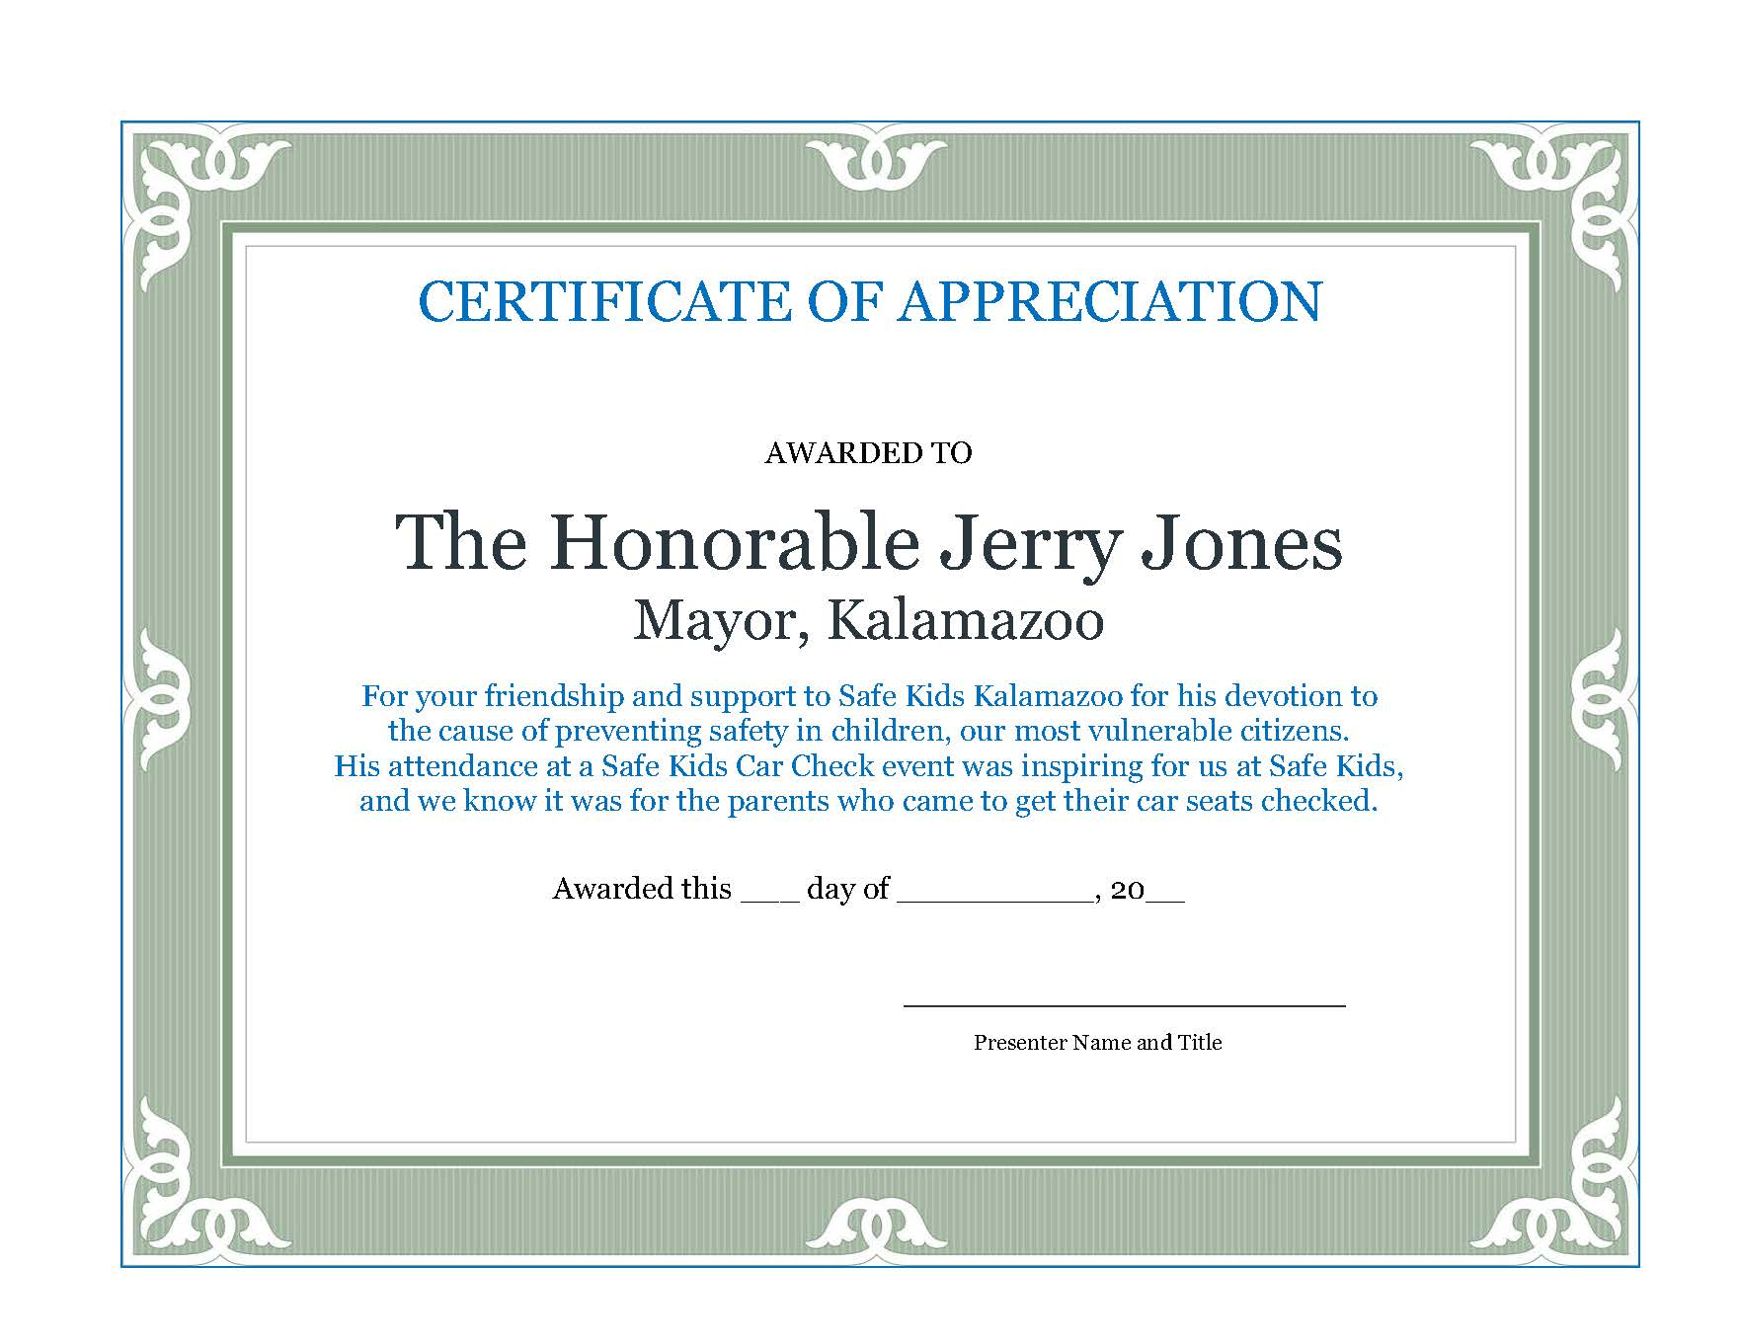

Sample Certificate of Appreciation