

1301 Pennsylvania Avenue, NW

Suite 1000

Washington, D.C. 20004

March 24, 2014

The Honorable Brian E. Frosh

Chair, Maryland Judicial Proceedings Committee

Miller Senate Office Building, 2 East Wing

11 Bladen St., Annapolis, MD 21401  
brian.frosh@senate.state.md.us

Dear Senator Frosh,

As educators and advocates on preventing car and road injuries involving children, we join together to add our support Maryland Senate Bill 87, requiring repeat offenders of alcohol and/or drug related driving provisions to either submit to a suspension of the driver’s license for one full year or agree to and complete one full year of participation in the Ignition Interlock System Program (IISP). We thank you for your leadership.

According to the CDC, 226 children were killed in drunk driving crashes in 2012, and over half of those children were being driven by a drunk driver. Impaired drivers continue to be a serious safety risk for children in motor vehicles. Further, one third of all driving while intoxicated (DWI) or driving under the influence (DUI) arrests each year involve repeat offenders. We know that IISP programs are successful in Maryland. Since the Drunk Driving Reduction Act went into effect in 2011, over 4,400 new drivers have started in the ignition interlock program. In addition, according to the 2008 final report of the Maryland Task Force to Combat Driving under the Influence of Drugs and Alcohol, when offenders are required to use ignition interlock devices, recidivism is reduced by at least 60% and as much as 95%.

Traffic crashes are the leading cause of death for children. They are kids like 7-year-old Jan-nae Alicia Woodard of Waldorf, who was killed in June 2012 when a driver swerved, crossed the median and hit Jan-Nae’s mom’s car. Jan-Nae was seated in a booster seat. The driver of the car which hit her was under the influence of alcohol. The passing of MD SB87 can improve the safety of the roads and prevent tragedies like this. Safe Kids thanks you for exercising your leadership in introducing this important bill.

Thank you for your support on this important safety initiative.   
  
Sincerely,

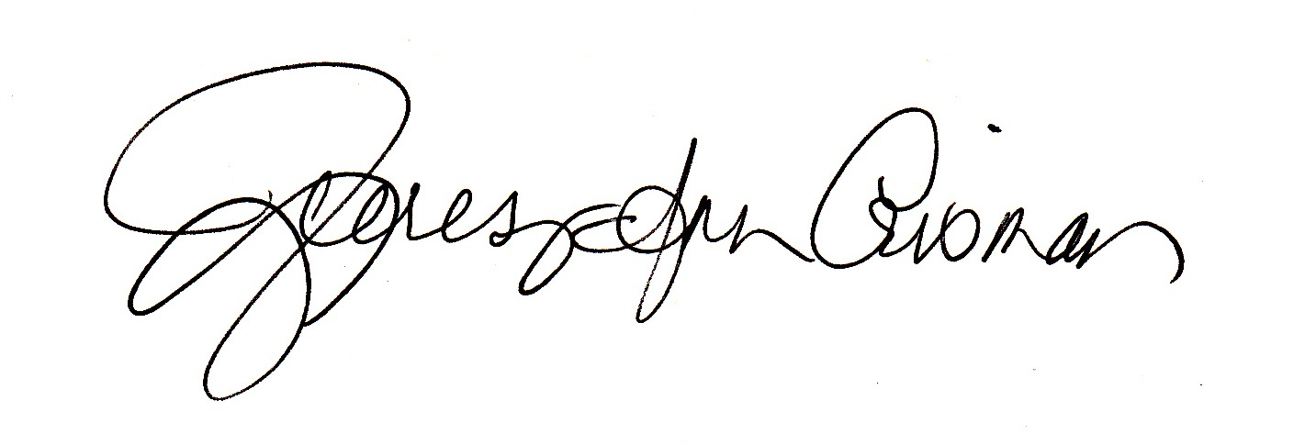

Anthony Green Emilie Crown Teresa Ann Crisman  
Director, Public Policy Coordinator Coordinator  
Safe Kids Worldwide Safe Kids Montgomery County Prince George’s County