Heatstroke Social Media Guide 2020
This guide provides suggested Tweets and Facebook posts to help raise awareness about heatstroke prevention. It also has suggestions for social media posts following an incident of heatstroke in your community.

Facebook Posts
We ask that you join our efforts to help sound the alarm about heatstroke. We have supplied you sample posts you can use on Facebook (below).

We are also asking everyone to post a message about heatstroke on the first Wednesday of every month (April – October). Prior to that day, we will email posts that are more targeted to recent events. Please join the email list by clicking here.

If you want to post at different times throughout the summer, we have a few generic posts to use or modify as you see fit.

Generic Posts
- More than half of child heatstroke deaths occur because a caregiver has forgotten the child in the car. It can happen to even the most caring parents. Help prevent another tragedy. Leave something in the backseat you need at your final destination so you’ll remember to check that backseat before you leave. Learn more: http://bit.ly/1fT7GgB

- [Insert number children who have died in 2020] kids have already died from heatstroke in hot cars this year. Help prevent another tragedy. If you see a child alone in a car, call 911. Emergency personnel are trained to respond to these situations. One call could save a life. http://bit.ly/1gy2XPR

- Did you know how hot the inside of a car can actually get? We hit the streets and asked people to guess? When we revealed the answer, the reactions were amazing. http://bit.ly/1vZKIym

- Heatstroke doesn’t only happen on hot days. Children are still at risk even in cooler temperatures because of how quickly a car can heat up. If you see a child alone in a car, call 911. You don’t know how long they’ve been there, so don’t waste any time. You can save a life. http://bit.ly/1gy2XPR

- Help protect kids from heatstroke by remembering to ACT: Avoid heatstroke. Create reminders. Take Action. Learn more: https://www.safekids.org/infographic/steps-prevent-heatstroke

- Your car heats up faster than you think. The inside temperature can rise 19 degrees in 10 minutes so before you know it cars can become unsafe for children and pets. Never leave a child or a pet alone in a car, not even for a minute. http://bit.ly/1gy2XPR

- What should you do if you see a child alone in a car? Dial 911. Emergency personnel are trained to respond. http://bit.ly/1gy2XPR

Twitter
General Tweets
- If you see a child alone in a car, call 911. Experts will know what to do. You could save a life: http://bit.ly/1Rya76V

- In just 10 minutes a car’s temperature can increase by 19 degrees – and it continues to rise. #heatstroke http://bit.ly/1dtPS9M

- #Heatstroke can happen to anyone, anywhere. Learn tips so it doesn’t happen to you or your loved ones: http://bit.ly/1fT7GgB

- Tip: Make sure to keep your car locked when you’re not in it so kids don’t get in on their own. http://bit.ly/1gy2XPR #heatstroke

- Every 10 days a child dies from being left in a hot car. Help prevent #heatstroke. http://bit.ly/1fT7GgB

- More than half of reported #heatstroke deaths occurred when a distracted caregiver forgot their child was in the car http://bit.ly/1fT7GgB

- We can cut down the number of #heatstroke deaths and near-misses by remembering to ACT! Find out how http://bit.ly/1gy2XPR

- Remember to never leave a child alone in a car – not even for a minute! http://bit.ly/1fT7GgB #heatstroke

- Help us spread the word to prevent #heatstroke. http://bit.ly/1fT7GgB

- What should you do if you see a child alone in a hot car? Dial 911 immediately. http://bit.ly/1gy2XPR #heatstroke

Suggested Hashtags: #heatstroke, #CheckForBaby, #HeatstrokeKills

Images

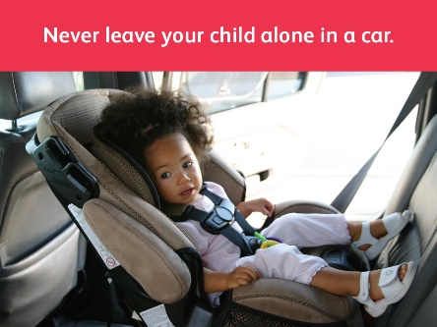
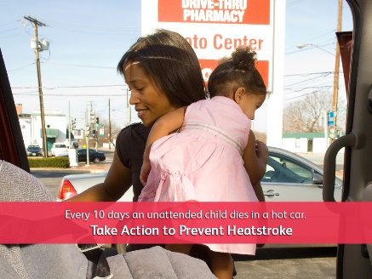

More Information

For more information, please contact Madeline Tucker at Safe Kids Worldwide at 202-662-0611 or
mtucker@safekids.org.

Visit www.noheatstroke.org to find the current fatality data and statistics for your social media.

